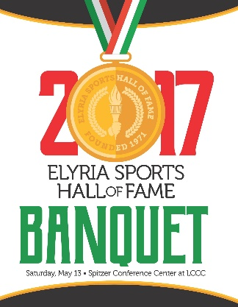

Elyria Sports Hall of Fame
P.O. Box 1462
Elyria, OH 44036-1462

Dear Perspective Patron,

The Elyria Sports Hall of Fame has been honoring outstanding athletes from Elyria’s high schools since 1971. One important part of this effort is our May banquet. The program for the banquet includes the past inductees, patrons, current inductees, special honors, and advertisements from our supporters throughout the community.
We are asking you to help continue this tradition by advertising in our 2018 banquet program.
To help, you need only complete and return the order slip at the bottom of the page. The lay out will be professionally done, and may be constructed from anything from a full page copy to a business card.
Please include the copy with the form below.
We would like to have the forms returned at your earliest convenience to facilitate printing.
My e-mail is: reflarry@oh.rr.com

Thank-you

Larry Dixon
Program Chairman
440-309-4189

Elyria Sports Hall of Fame
Program order Form 2018 Banquet
(Sorry, all ads will be in black and white)

Quarter Page Ad. $50.00 Company Name ____________________________________

Half Page Ad. $85.00 Address ___________________________________________

Full Page Ad. $150.00 Contact Person_____________________________________

(Circle your choice) Phone # __________________________________________

e-mail ___________________________________________

Please send checks & order information to: ESH of F, P.O. Box 1462, Elyria, Ohio 44036-1462

